* What threshold of db is considered safe for orcas?
  + 100db in either 63 or 125 Hz ⅓ octave band
  + Acute and chronic impacts on animals
    - Acute
      * No threshold set in canada yet
      * Instant effects on an animal
      * Organ damage, hemorrhaging, death
    - Chronic
      * Lower level sounds
      * Stress
      * Longterm exposure
      * Interfere with echolocation
  + Quiet Vessel Initiative
    - Canada
    - Transport Canada
    - Fund research into making the ocean safer for marine mammals
    - tc.canada.ca/en/programs/quiet-vessel-initiative
    - Giving early warning to mammals, cut your engines into port
    - No work yet done on hull design, propellor design
      * Mobius propellors? Toroidal Propellors!
      * <https://ntrs.nasa.gov/citations/20010088092>
      * <https://www.youtube.com/watch?v=MGy8jvf-DZ0>
      * <https://www.youtube.com/watch?v=0e_msu-wS6k>
* Are there any BC laws that limit marine db levels?
  + No, thresholds set by europe
* Does ONC have access to AIS Ship Tracking APIs?
  + Yes
* Does ONC have hydrophones in known orca hotspots and water highways?
  + Yes
  + Anywhere we have a node or observatory community
* No restrictions to theoretical, external software development

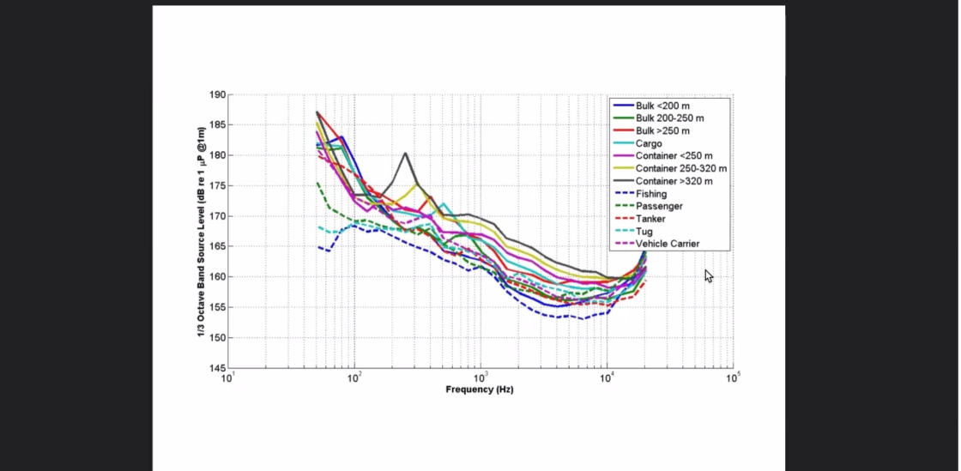

* Things to consider
  + Accessibility
    - W3C guidelines
  + Interactive elements of your dashboard

I think we could propose something simple: live DB readings from hydrophones combined with AIS ship tracking. It tells you what ships are in that area, how big they are, and how fast they're going. We can have an app that targets specific ships and asks them to slow down until the hydrophones pick up an acceptable DB level

* Dave loved it!
* Quiz
  + Importance of verbs section
  + Module 6.2 Style Matters
  + Sentence Structure
  + 45-60 minutes

The 7C’s of Effective Communication

* Clear
  + Purpose / goal oriented
  + Match vocabulary to the audience
* Coherent
  + Flow well, logical, organized
  + Transitional words, headings, structure
  + No random / irrelevant points
  + Consistent tone
* Concise
  + Clear meaning, least amount of words as possible
    - Active verbs
      * “Emily ate tacos”
      * “Tacos were eaten by emily
* Concrete
  + Paint a picture in the reader’s mind
  + Examples, analogies, measurable descriptors
* Correct
  + No typos
  + Standard sentence structure and grammar
  + Insure information you provide is accurate
  + Appropriate document type
* Complete
  + Checklist for yourself before you start writing
  + Answer all relevant questions
  + Be specific in your writing
* Courteous
  + Friendly for the reader
  + Easy readability
  + Avoid offensive language
* Friday is more review
  + The importance of verbs verbs (textbook)
    - Clause
    - Phrase
    - Active
    - Passive
  + How to revise a document
    - 4 steps
    - Commas
  + Take home quiz over the weekend
    - Due Monday at midnight
  + Include work logs in your appendices!! (In your final assignment)